Online Job Portal System

Project submitted to:
Professor Khalid Jamal


Designed by:
Farhana Ghayas (R-10)

For any details, doubts, questions about project concept
Contact at
Email ID: farhana.capricon@gmail.com

© MAY 2015 Farhana. All Rights reserved.

Acknowledgment
First and foremost we would like to thank Professor. Khalid Jamal for giving us a chance to work in this project and giving us an opportunity to enhance our technical skills before joining any software house. I would like to thank my family, friends for supporting us so that we could focus on our work. And mentors specially Miss Misbah Anwar for guiding us, your suggestions help us to improve our project.
Finally, I would like to thank all of them whose names are not mentioned here but have helped us in some way to accomplish the work.
Farhana Ghayas

Abstract
In the current scenario, there is a rat race in each and every professional field. It is also true for job market. A job portal is a website dedicated for online information about recruiters as well as job seekers.
A job portal helps both the job seekers and recruiters finding the right organization for the employees. Job Seekers can find jobs according to their educational qualification, experience and their preference, the job portal shows that list of companies to the job seeker. And, to the recruiters, provides the suitable candidates from a pool of lacks.
So, a job portal is the perfect online arena, where both the job seekers and the employers find their goal in the pursuit of getting a top notch company for the suitable candidates.

Contents
INTRODUCTION 5
1.1 About Project: 5
1.2 Modules: 5
1.3 Definitions, Acronyms and Abbreviations: 5
REQUIREMENT ANALYSIS 6
2.1 Functional Requirements: 6
2.1.1 Admin: 6
2.1.2 Employer: 6
2.1.3 Job Seekers: 7
2.2 Non-Functional Requirements: 7
2.3 Hardware Requirements: 8
2.4 Software Requirements: 8
SYSTEM DESIGN: 9
3.1 Use Case Diagram: 9
3.3 Data Flow Diagram: 11
3.3.1 Context Diagram : 11
3.3.2 Level 0 : 12
3.3 Screen-shots: 14
3.3.1 Home Page: 14
3.3.2 Login Page: 15
3.3.3 Registration Page: 15
3.3.4 Employer Control Panel: 16
3.3.5 Jobseekers Control Panel: 17

INTRODUCTION

1.1 About Project:
Online job portal is a web application built in asp.net. Online Job Placement Website is aimed at computerizing the activities involved Job seeking and recruitments. The prime activities figured out in this process include find suitable company, etc. It provides the candidates, ability to register to this application and search for jobs, manage their accounts. Each candidate will have an account with their own home page.
On the other hand, Employers those are willing to publish the jobs for their company to candidates, can register to the job portal and get their own account created and can post jobs to portal's database. Registered Employers can add or remove jobs and these jobs can be seen by various candidates and they can contact the concern person for the job. Main aim of this web application is to make an user friendly platform where, applicant can search jobs easily and is accessible to everyone who are interested.
The Purpose of the application is to provide Job portal for Job Seekers, to submit their CV and apply for job, where Employer can select best Employees from available candidate profile. The candidate can input his/her requirement according to their needs and perform search operation to get their ideal job.

1.2 Modules:
The main users in the project can be categorized into three modules as follow:
1. Admin
2. Employer
3. Jobseeker

1.3 Definitions, Acronyms and Abbreviations:
1. Admin: The authorized person who controls the entire network
2. Employer: Who creates vacancies?
3. Jobseekers: The person who sells applies for job

REQUIREMENT ANALYSIS

2.1 Functional Requirements:
In this section we will briefly discuss different functional requirement of different users.

2.1.1 Admin:

- Manage Job Seeker and Employer Profiles.
- Add New Services, Related to Employers or Job Seekers.
- Send Message to Employer and Job seeker for Subscription etc.
- Provide Roles and Authentication to Users.
- Ability to change the look and feel of your site by changing template.
- Most Recent Jobs to be displayed on home page.
- Search jobs based on keywords, categories, locations etc.
- Create / Edit / Save as many icon sets as you like.
- Location management console to add/edit/remove locations for which jobs can be posted.
- Manage premium employers.
- Admin can Add/Edit/Delete/Approve/Disapprove any job.
- Private labeled and fully integrated with your existing web site's look and feel.
- Search Job seekers and Employers on the basis of Keyword, name, Email-address, Country, etc.
- Manage Featured Employers Showcase.

2.1.2 Employer:
- Ability to Search resume by keywords, job category, days since posted.
- Post jobs with detailed job description (job title, company name, company url, location, salary, job type, work type, description, required skills...)
- Ability to create and edit a company profile.
- Ability to add a Company Logo.
- Retrieve passwords reset by automated email.
- Employer Registration
- Information on number of vacancy viewings and applications
- Register and sign-up online for Memberships, Job packages, job postings or resume database access.
- Option of including company profile and logo.
- Retrieve passwords by automated email.
- Update profile at any time.
- View Submitted Job Seeker CV.
- Download CV or application submitted by jobseekers.

2.1.3 Job Seekers:
- Apply for a job with the click of a button
- Resume Posting.
- Automatically retrieve passwords by email.
- Job Seeker Registration
- Login and update profile, including forgotten password reminders
- Powerful online job search tool.
- Job seeker sets 'privacy level' to control how much information is visible to employers through resume searches.
- Search jobs by location, qualification, categories, company, location, experience and keywords.
- Hide contact information.
- Add multiple list of qualification and experience.
- Ability to add and submit Photos to profile.
- Ability to add Cover Letter when apply for job.

2.2 Non-Functional Requirements:
1. Secure access of confidential data (user's details).
2. 24 X 7 availability
3. Better component design to get better performance at peak time.
4. Flexible service based architecture will be highly desirable for future extension.
5. User friendly environment that attracts the peoples.

2.3 Hardware Requirements:
- Processor : Intel Pentium And Above Version
- Speed : 1.60 GHz
- Hard Disk : 20GB And Above
- Key Board : Standard

2.4 Software Requirements:
- Operating System : Windows 7
- Data Base : Microsoft SQL Server Management Studio 2012
- IDE : Microsoft Visual Studio 2012
- Tools : C#, Java Script, JQUERY, HTML5, CSS

SYSTEM DESIGN:
Systems design is the process or art of defining the architecture, components, modules, interfaces, and data for a system to satisfy specified requirements. Object-oriented analysis and design (OOAD) methods are becoming the most widely used methods for computer system design. The UML has be-come the standard language used in Object-oriented analysis and design. It is widely used for modeling software systems and is increasingly used for high designing non-software systems and organizations.

3.1 Use Case Diagram:
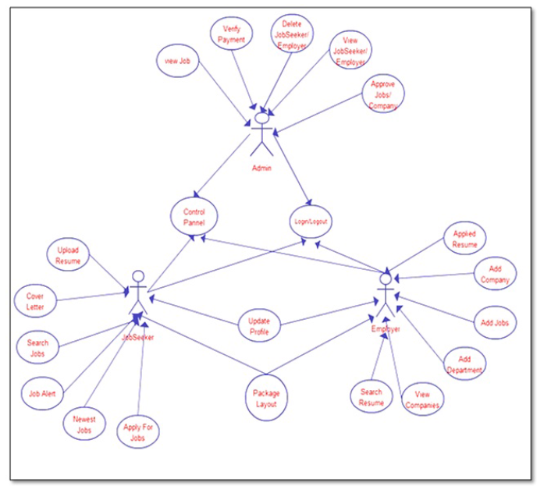
Figure 1: Use Case Diagram

3.2 Sequence Diagram:
s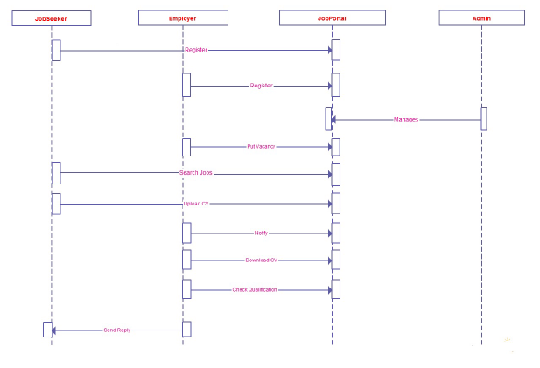
Figure 2: Sequence Diagram

3.3 Data Flow Diagram:

3.3.1 Context Diagram :
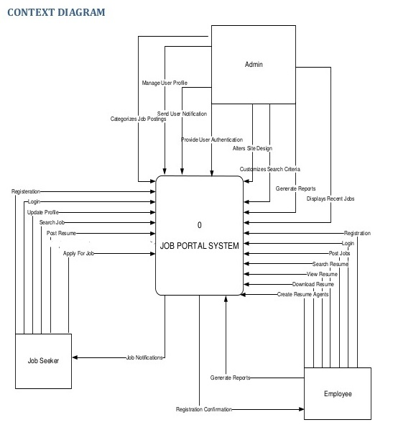

3.3.2 Level 0 :
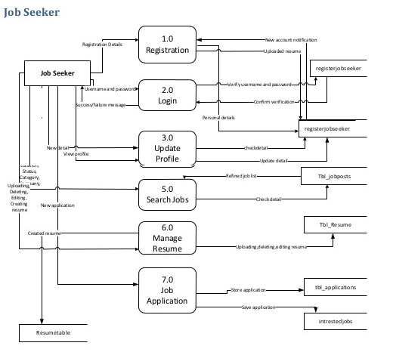
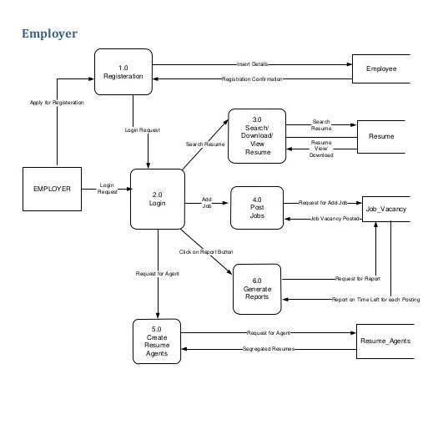

3.3 Screen-shots:

3.3.1 Home Page:
The first page of our website having information about the companies and featured jobs that can be see by any user either register or not.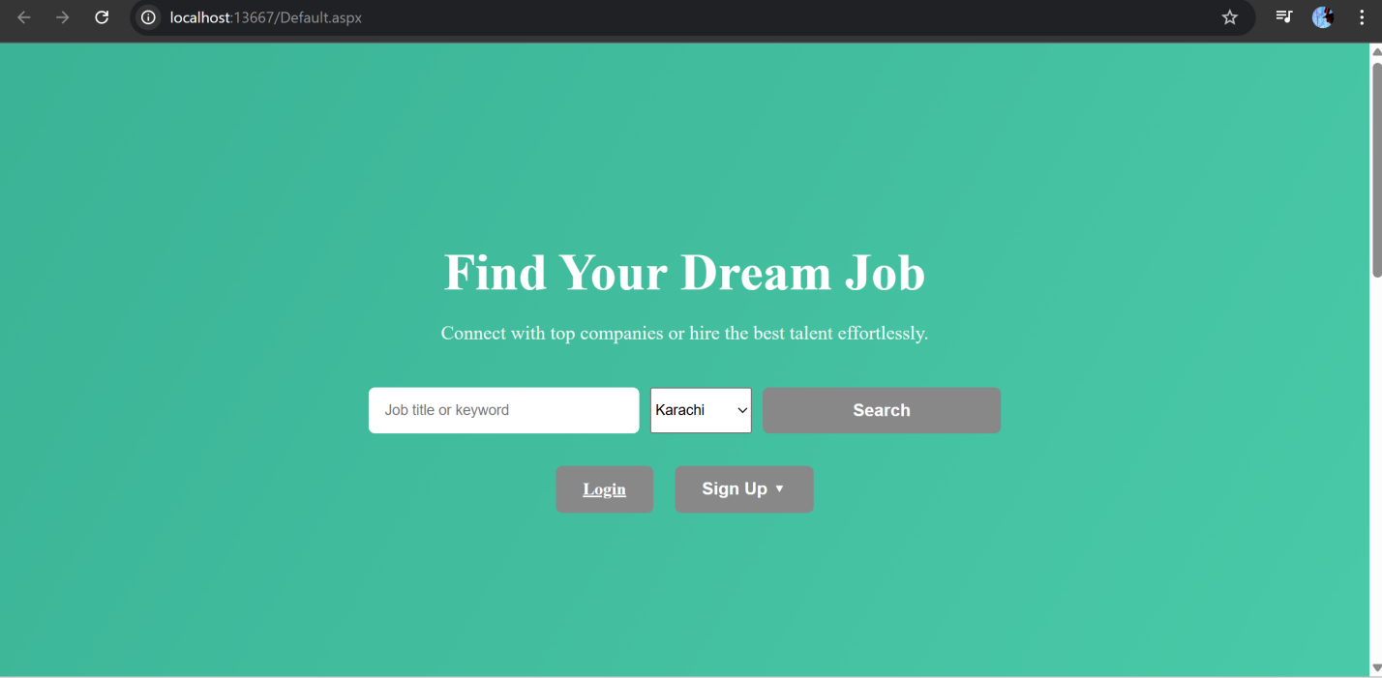
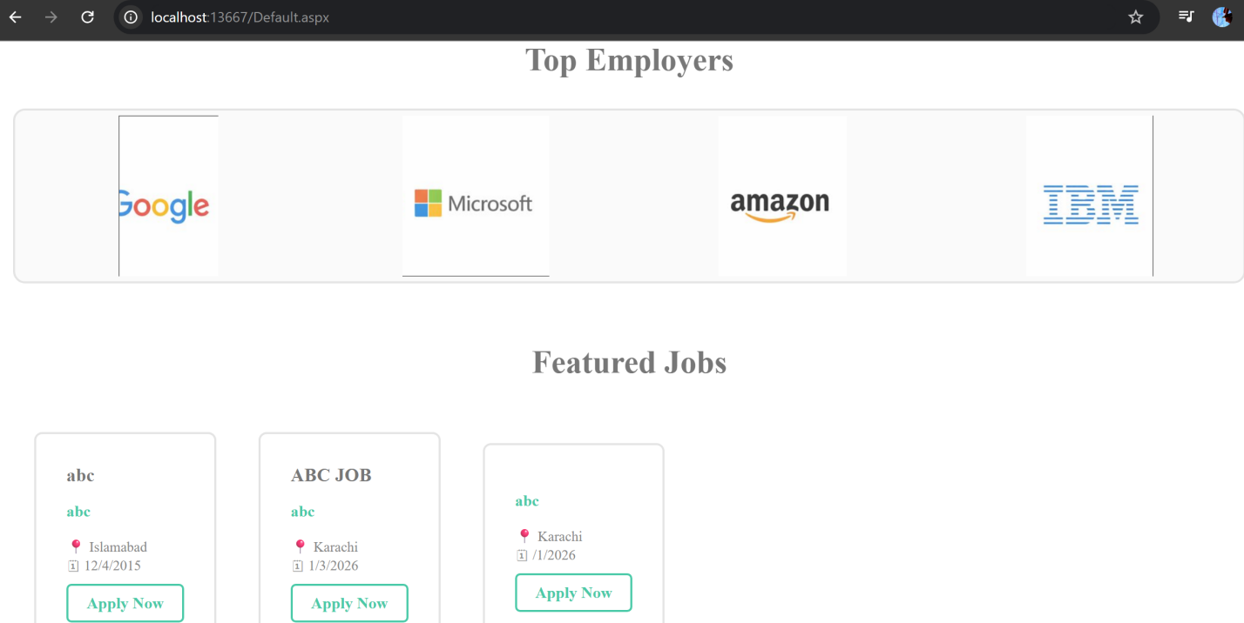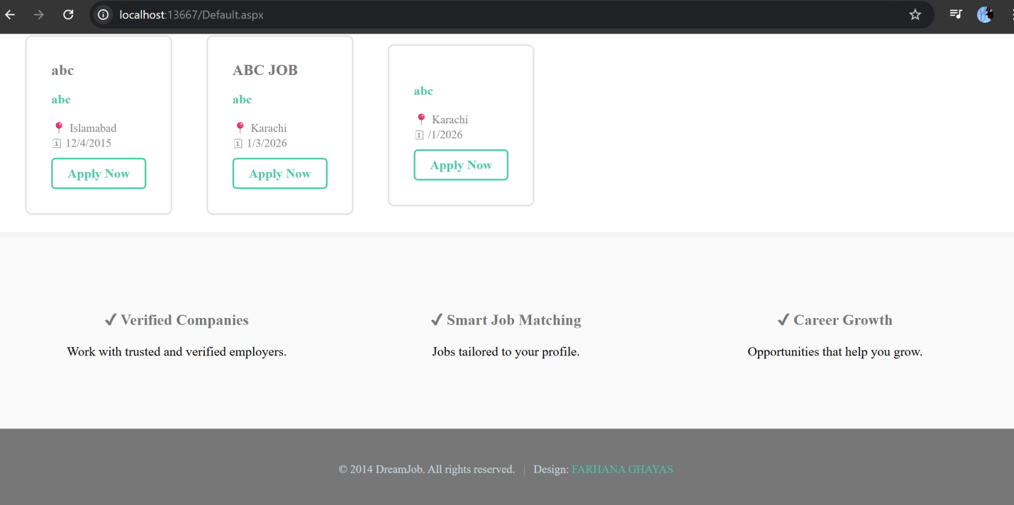

3.3.2 Login Page:
A registered user can sign in and can all the features that are provided by our website depending upon the nature of his/her role if a person is registered as jobseeker than he/she can enjoy jobseeker features only, similarly for the recruiter.
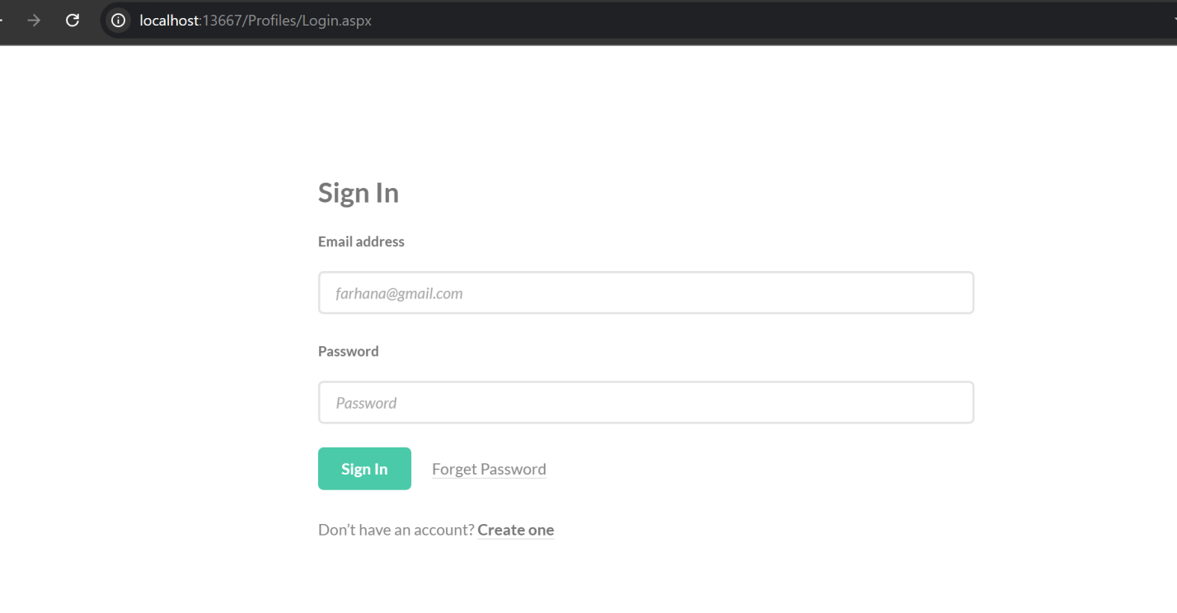

3.3.3 Registration Page:
To register User will fill the form and provide all the required information to make his/her complete Profile.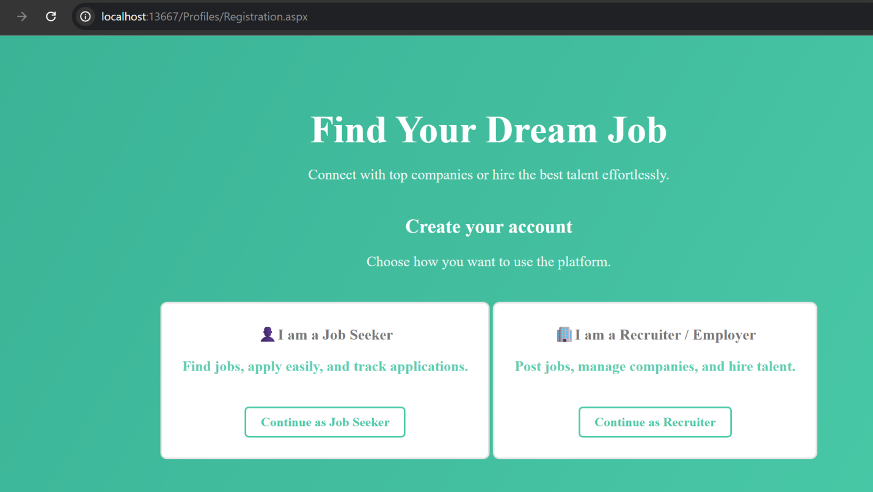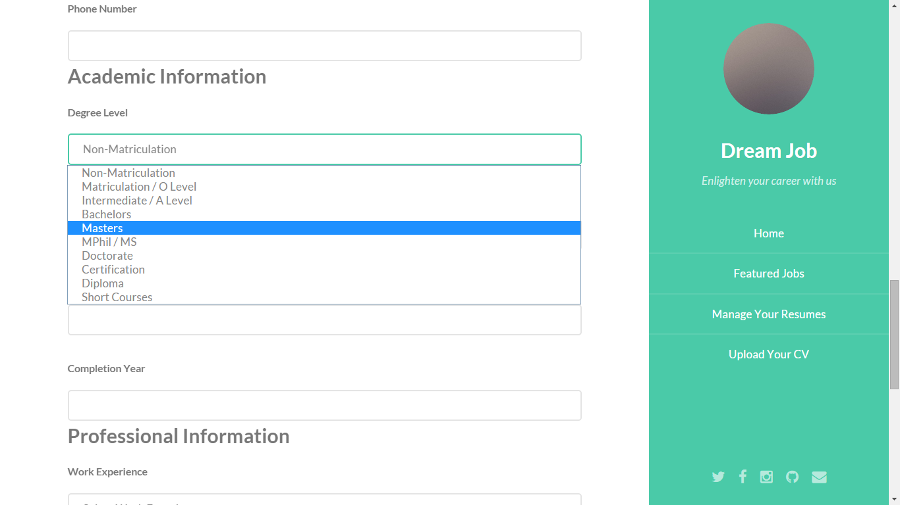

3.3.4 Employer Control Panel:
Once a Recruiter is login he/she can post a job, can edit company profile and view all the posted jobs by that person. All the information of interested Jobseekers who has applied for this job is also appear in this panel. Recruiter Access information and select the candidates. If a person is selected than a notification is send to that person.
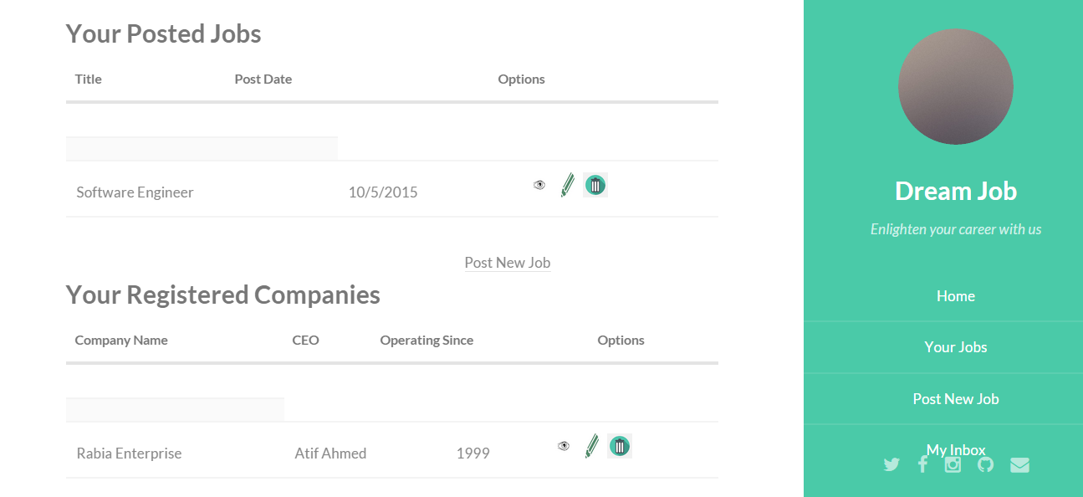
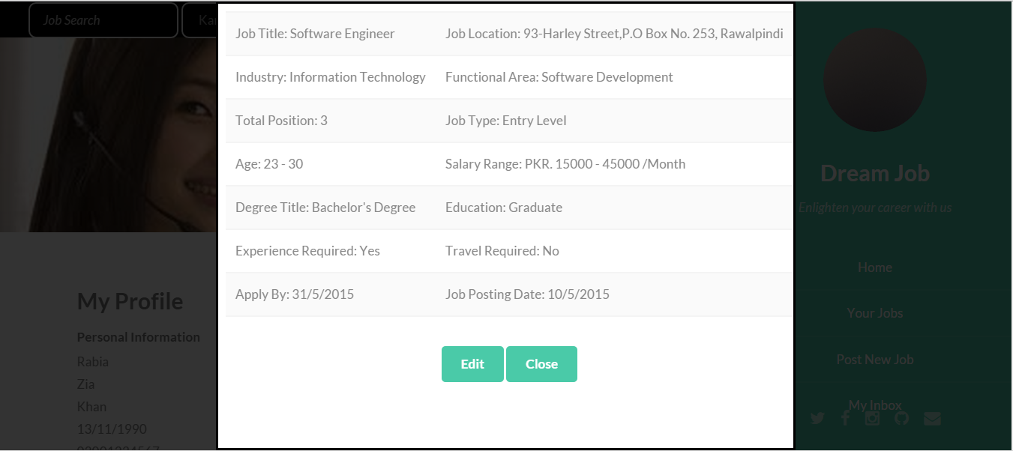
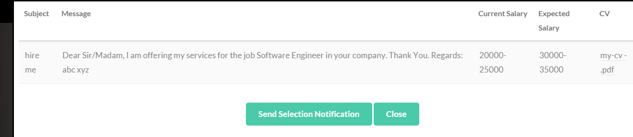

3.3.5 Jobseekers Control Panel:
Once a jobseeker is login, His/her Profile information is appearing. The User can edit his/her information by clicking a button “Editable”.
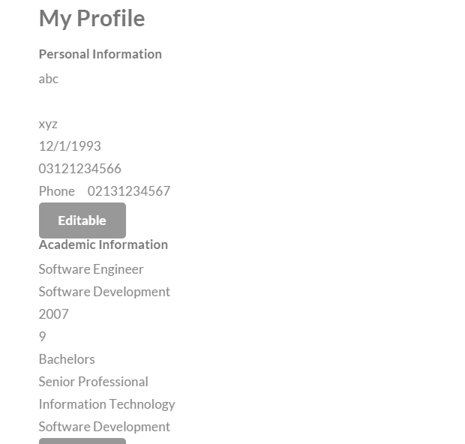

The jobseeker has a mailbox in case of that candidate is selected by the recruiter for the job interview than notification is appeared. 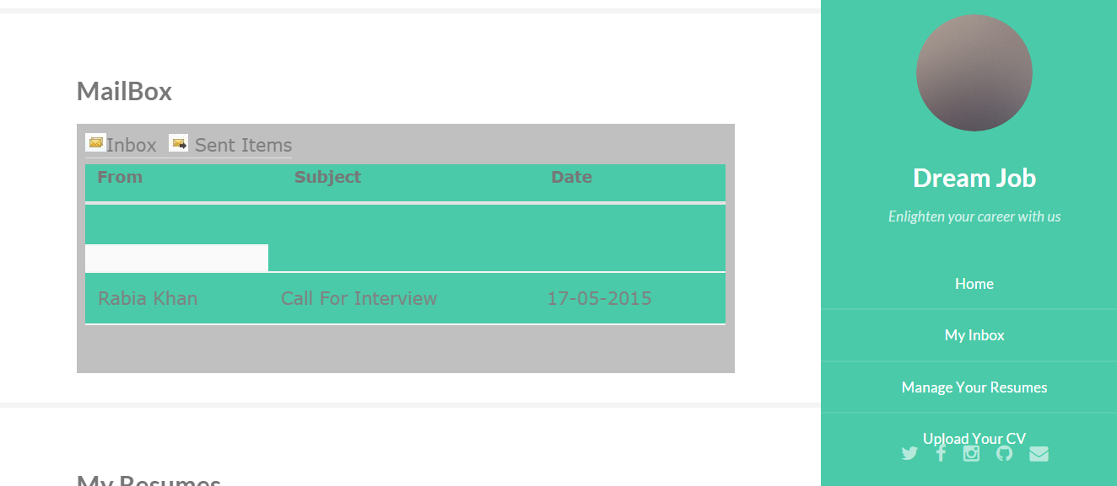
The jobseeker can upload his/her CV which is in MS word format.
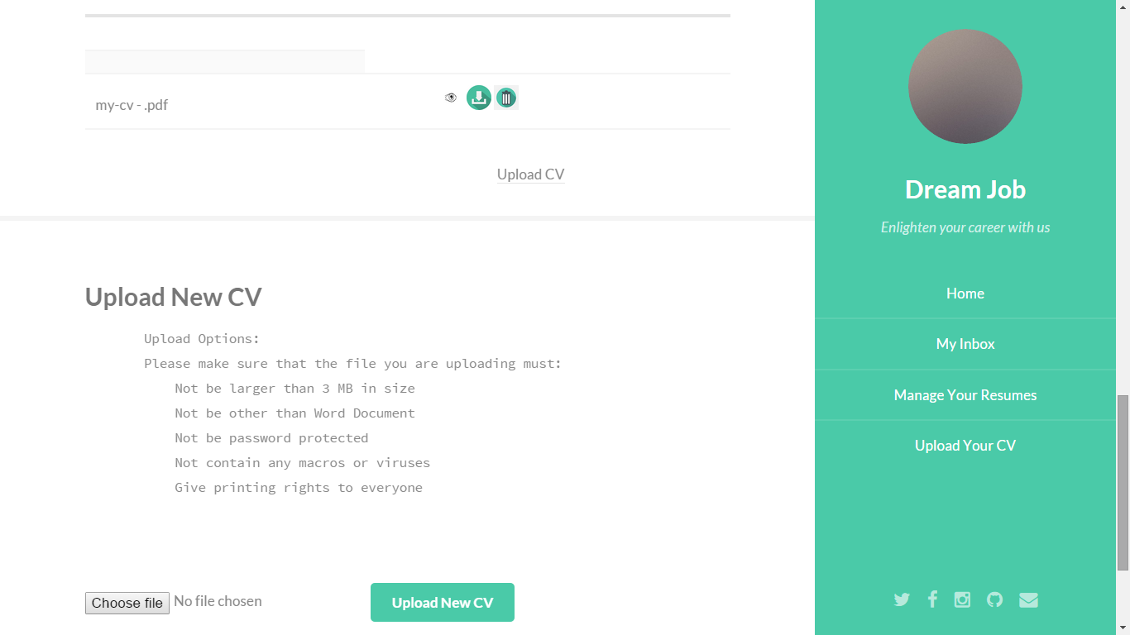
Jobseeker can search job by Job title and location than job information is appeared.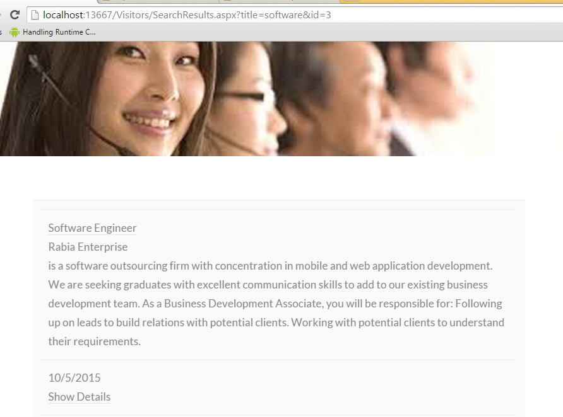
For the jobs that are appeared on the job seeker panel he/she can apply for the job by providing CV, current salary, subject and Cover letter.
